Fundamentals of Machine Learning Assignment 1

* Download a dataset from the web.

Dataset collected from *https://www.kaggle.com/datasets/benroshan/factors-affecting-campus-placement*

* Import the dataset into R

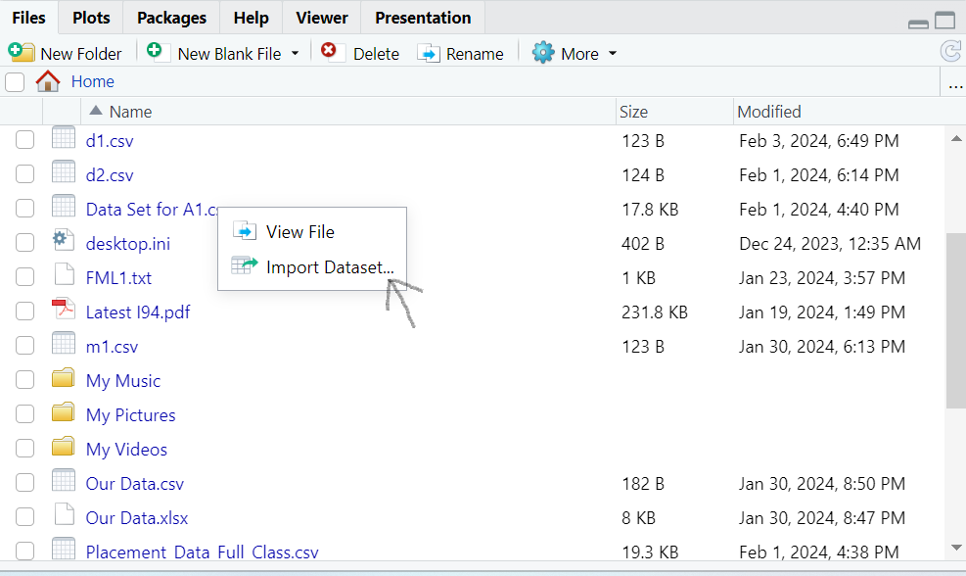

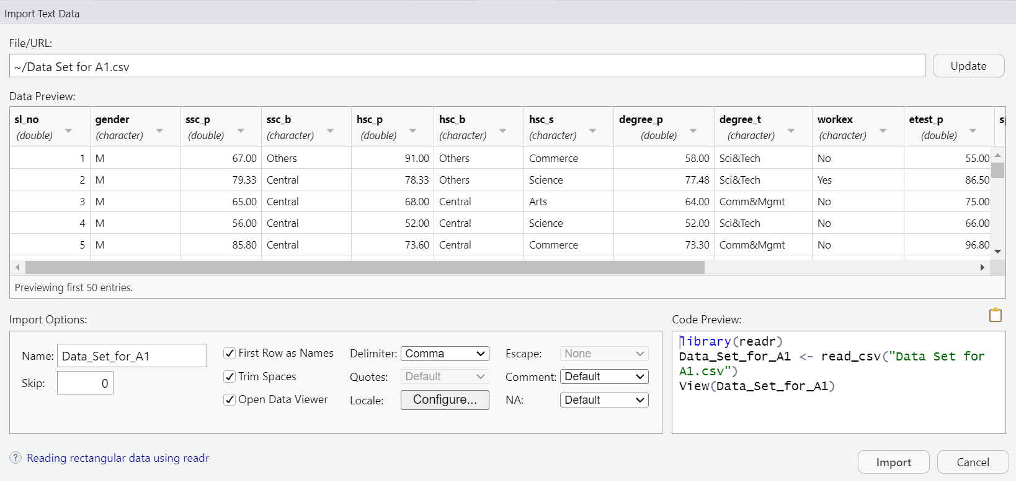

* Print out descriptive statistics for a selection of quantitative and categorical variables.

Line No.19

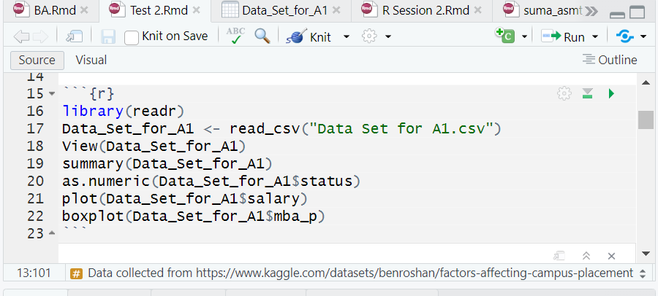

* Transform at least one variable. It doesn't matter what the transformation is.

Line No.20



The variable “Status – placed/not placed” has been transformed to numeric using “*as.numeric(Data_Set_for_A1$status”*.

Since the variable selected is categorical and the transformation into numeric is not possible we got warning & “NA” in response.

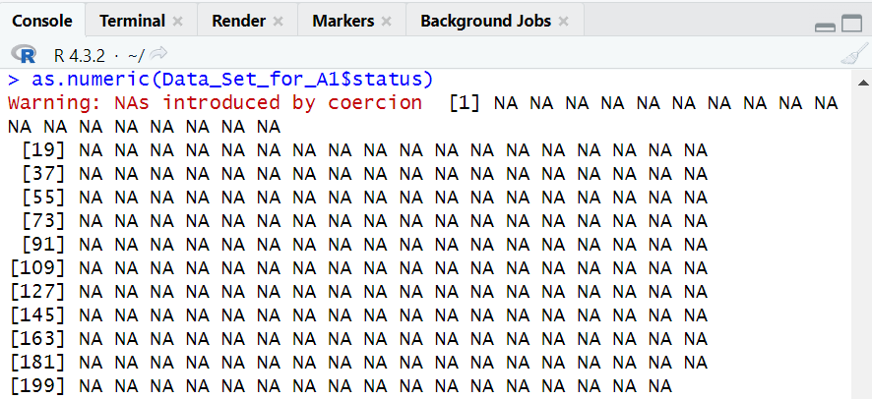

* Plot at least one quantitative variable, and one scatterplot

Scatter plot for variable Salary has been plotted.



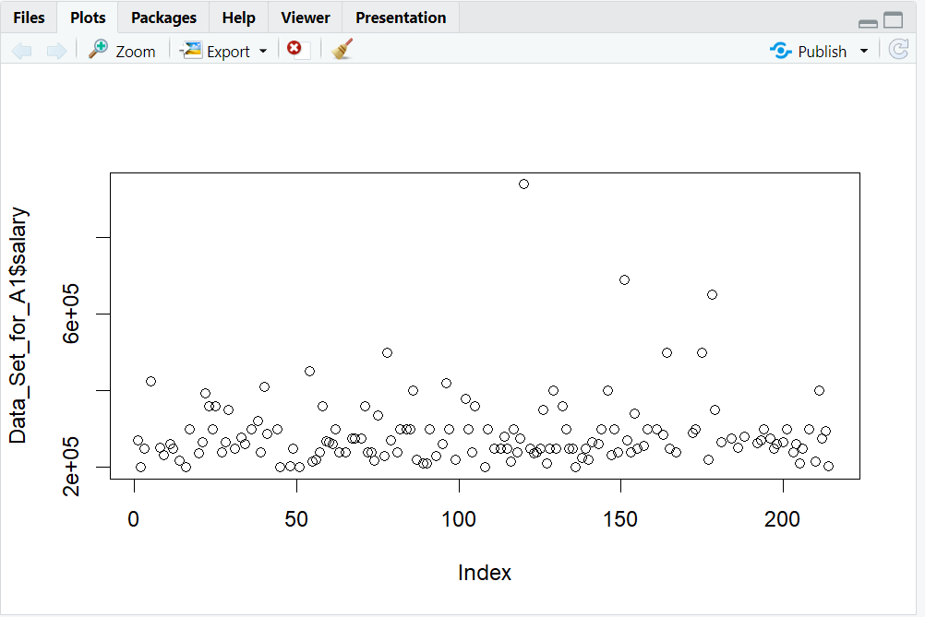

Among 200 members most of their salaries lies in the range of 2,00,000-3,00,000.

Box plot has been plotted for variable “mba_p” (MBA percentage)

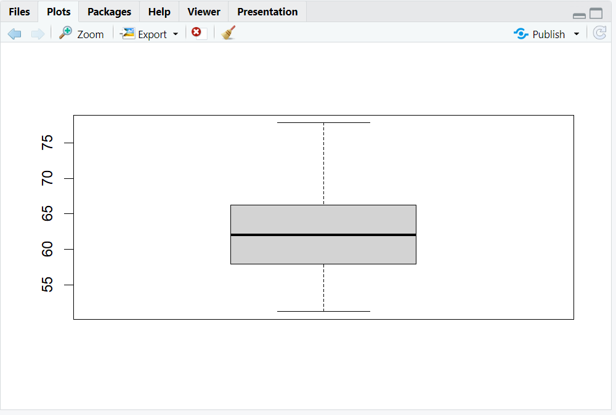

Min percentage: 51.21

Max percentage: 77.89

Median: 62:00

Mean: 62:28